**PROJECT ON**

**Air ticket reservation**



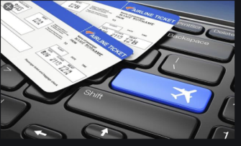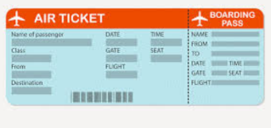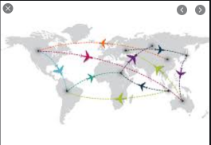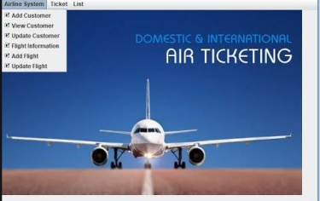

**Submitted by** : Swaroop2sky

**Class** : XII A

CERTIFICATE

CLASS: XII-A YEAR: 202x-20xx

This is to certify that Investigatory Project is successfully completed by …..………………… of Class: XII, Division: A

Roll no. :……………….. for the academic year 202x-20xx in the School Computer lab.

Head Teacher External Internal Examiner Signature: Examiner (Subject Teacher)

Date: / / 20 Department of: COMPUTER SCI.

Principal

**Acknowledgement:**

We, Swaroop2sky and Swaroop2sky of class XIIth- A

would like to express our sincere gratitude to our computer science teacher Ms. Teacher Name, PGT COMPUTER SCIENCE, for her vital support, guidance and encouragement – without which this project would not have come forth.

We would also like to express our gratitude to our school School Name for letting us use the school laboratory.

**INDEX**

1. Brief Overview of Project
2. Need for Computerization
3. Software and Hardware requirement
4. Advantages of Project
5. Limitations of Project
6. Source Code of Project
7. Output Screens
8. Future Enhancement of Project
9. Bibliography

**AIR TICKET RESERVATION**

BRIEF OVERVIEW OF PROJECT

The main objective of the python project on Air ticket reservation is to manage the details of booking, payments, seats, and flights.

The project is totally built at administrative end and only administrator is guaranteed the access.

The purpose of the project is to build an application program to reduce the manual work for managing the booking, discounts, seats, and payments.

It tracks all the details about seats, flight, and payments; it also prints various reports as per input given by the user.

**INPUT DATA AND VALIDATION OF PROJECT**

1. All the fields such as flight payments discounts are validated and does not take invalid values.
2. Each form of sales, discounts, bookings cannot accept the blank values.
3. Avoiding errors in data.
4. Controlling amount of input.

**SOFTWARE AND HARDWARE REQUIREMENTS:**

**Data file handling** has been effectively used in the program. The database is a collection of interrelated data to serve multiple applications. That is database programs create files of information. So we see that files are worked with most, inside the program.

**DBMS:** The software required for the management of data is called as DBMS. It has3 models:

• Relation model

• Hierarchical model

• Network model

**RELATIONAL MODEL:** It’s based on the concept on relation. Relation is the table that consists of rows and columns. The rows of the table are called tuple and the columns of the table are called attribute. Numbers of rows in the table is called as cardinality. Number of columns in the table is called as degree.

**HIERARCHICAL MODEL*:***In this type of model, we have multiple records for each record. A particular record has one parent record. No chide record can exist without parent record. In this, the records are organized in tree.

**NETWORK MODEL:**In this, the data is represented by collection of records and relationship is represented by (ink or association.

**CHARACTERISTICS OF DBMS:**

• It reduces the redundancy

• Reduction of data in inconsistency

• Data sharing

• Data standardization

**DIFFERENT TYPES OF FILES: -BASED ON ACCESS**:

• Sequential file

• Serial file

• Random (direct access) file BASED ON STORAGE:-

• Text file

• Binary File

**NEED OF COMPUTERISATION**

Over the decades computers and air ticket bookings have developed gradually, changed with time. But nobody knew that a time will come when both these fields will complement each other so well. Today air ticket booking has reached new heights by computer aided methods of design. As a result of which, computer industry has got its new customer. Computer technology is making waves in the flight booking zone. Computers are a vital component of the ticket booking counters. Computer aided design (CAD) programs reduce the demand for manual sketches. New software programs continue to replace old manual skills. Those who lag in math can now breathe a little easier.Manually figuring of tickets insists that knowledge. Software programs constantly evolve. A program used today may be obsolete within several years. Being trained on today's software does not guarantee it will be used when you are ready to go out into the field. Understanding calculations is timeless, as is computer competency. Software, however, shifts rapidly.

**ADVANTAGES**

1. It generates the report on sales, discounts and flights.
2. Provides filter report on payments and flight booking.
3. We can easily export PDF on sales, products and stocks.
4. Applications can also provide excel export for bookings and discounts.
5. It deals with monitoring the information and transaction of ticket bookings.
6. It increases the efficiency of flight booking and discount.
7. It has higher efficiency of editing, adding and updating of records.
8. Provides the searching facilities on various factors.

**LIMITS**

1. Excel export has not been developed for bookings.
2. The transactions are executed in offline mode only.
3. Online transactions for sales, bookings, or other data modifications are not possible.
4. Offline reports of sales, bookings, and discounts cannot be generated due to batch mode execution.

***Source codescreening***

**DBMS: MySQL**

**Host: local host**

**User: root**

**Pass: root**

**Database: hotel**

**Table Structure: (Images Bellow)**

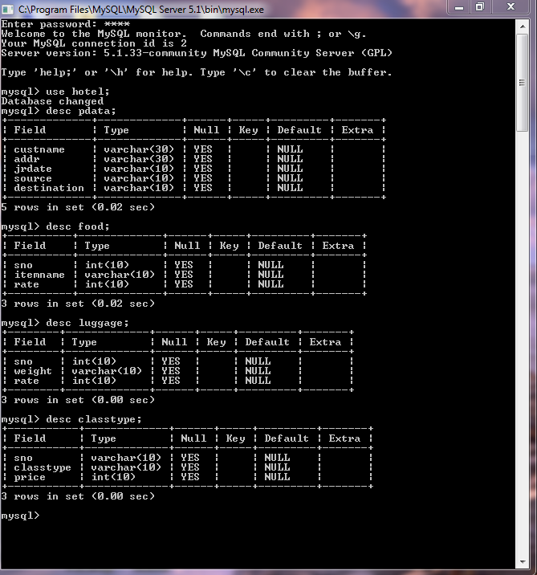

**PYTHON CODE:**

importos

import platform

importmysql.connector

import pandas as pd

importdatetime

mydb = mysql.connector.connect(user='root', password='12345',

host='localhost',

database='air')

mycursor=mydb.cursor()

defregistercust():

L=[]

name=input("enter name:")

L.append(name)

addr=input("enter address:")

L.append(addr)

jr_date=input("enter date of journey:")

L.append(jr_date)

source=input("enter source:")

L.append(source)

destination=input("enter destination:")

L.append(destination)

cust=(L)

sql="insert into pdata(custname,addr,jrdate,source,destination)values(%s,%s,%s,%s,%s)"

mycursor.execute(sql,cust)

mydb.commit()

defclasstypeview():

print("Do you want to see class type available : Enter 1 for yes :")

ch=int(input("enter your choice:"))

ifch==1:

sql="select * from classtype"

mycursor.execute(sql)

rows=mycursor.fetchall()

for x in rows:

print(x)

defticketprice():

print ("We have the following rooms for you:-")

print ("1. type First class---->rs 6000 PN\-")

print ("2. type Business class---->rs 4000 PN\-")

print ("3. type Economy class---->rs 2000 PN\-")

x=int(input("Enter Your Choice Please->"))

n=int(input("No of passenger:"))

if(x==1):

print ("you have opted First class")

s=6000*n

elif (x==2):

print ("you have opted Business class")

s=4000*n

elif (x==3):

print ("you have opted Economy class")

s=2000*n

else:

print ("please choose a class type")

print ("your room rent is =",s,"\n")

defmenuview():

print("Do yoy want to see menu available : Enter 1 for yes :")

ch=int(input("enter your choice:"))

ifch==1:

sql="select * from food"

mycursor.execute(sql)

rows=mycursor.fetchall()

for x in rows:

print(x)

deforderitem():

global s

print("Do yoy want to see menu available : Enter 1 for yes :")

ch=int(input("enter your choice:"))

ifch==1:

sql="select * from food"

mycursor.execute(sql)

rows=mycursor.fetchall()

for x in rows:

print(x)

print("do you want to purchase from above list:enter your choice:")

d=int(input("enter your choice:"))

if(d==1):

print("you have ordered tea")

a=int(input("enter quantity"))

s=10*a

print("your amount for tea is :",s,"\n")

elif (d==2):

print("you have ordered coffee")

a=int(input("enter quantity"))

s=10*a

print("your amount for coffee is :",s,"\n")

elif(d==3):

print("you have ordered colddrink")

a=int(input("enter quantity"))

s=20*a

print("your amount for colddrink is :",s,"\n")

elif(d==4):

print("you have ordered samosa")

a=int(input("enter quantity"))

s=10*a

print("your amount fopr samosa is :",s,"\n")

elif(d==5):

print("you have ordered sandwich")

a=int(input("enter quantity"))

s=50*a

print("your amount fopr sandwich is :",s,"\n")

elif(d==6):

print("you have ordered dhokla")

a=int(input("enter quantity"))

s=30*a

print("your amount for dhokla is :",s,"\n")

elif(d==7):

print("you have ordered kachori")

a=int(input("enter quantity"))

s=10*a

print("your amount for kachori is :",s,"\n")

elif(d==8):

print("you have ordered milk")

a=int(input("enter quantity"))

s=20*a

print("your amount for kachori is :",s,"\n")

elif(d==9):

print("you have ordered noodles")

a=int(input("enter quantity"))

s=50*a

print("your amount for noodles is :",s,"\n")

elif(d==10):

print("you have ordered pasta")

a=int(input("enter quantity"))

s=50*a

print("your amount for pasta is :",s,"\n")

else:

Print("please enter your choice from the menu")

deflugagebill():

global z

print("Do yoy want to see rate for lugage : Enter 1 for yes :")

ch=int(input("enter your choice:"))

ifch==1:

sql="select * from lugage"

mycursor.execute(sql)

rows=mycursor.fetchall()

for x in rows:

print(x)

y=int(input("Enter Your weight of extra lugage->"))

z=y*1000

print("your laundarybill:",z,"\n")

return z

def lb():

print(z)

def res():

print(s)

defticketamount():

a=input("enter customer name:")

print("customer name :",a,"\n")

print("lugage bill:")

print(lb)

print("food bill:")

print(“total amount”)

defMenuset():

print(“AIR TICKET RESERVATION”)

print("enter 1: To enter customer data")

print("enter 2 : To view class")

print("enter 3 : for ticketamount")

print("enter 4 : for viewing food menu")

print("enter 5 : for food bill")

print("enter 6 :for lugage bill")

print("enter 7 : for complete amount")

print("enter 8 : for exit")

'''try:

#userinput=int(input("pleaseselect an above option:"))

exceptValueError:

exit("\n hi thats not a number")'''

userinput=int(input("enter your choice"))

if(userinput==1):

registercust()

elif(userinput==2):

classtypeview()

elif(userinput==3):

ticketprice()

elif(userinput==4):

menuview()

elif(userinput==5):

orderitem()

elif(userinput==6):

lugagebill()

elif(userinput==7):

ticketamount()

elif(userinput==8):

quit()

else:

print("enter correct choice")

Menuset()

defrunagain():

runagn=input("\n want to run again y/n:")

while(runagn.lower()=='y'):

if(platform.system()=="windows"):

print(os.system('cls'))

else:

print(os.system('clear'))

Menuset()

runagn=input("\n want to run again y/n:")

runagain()

**OUTPUT SCREEN**

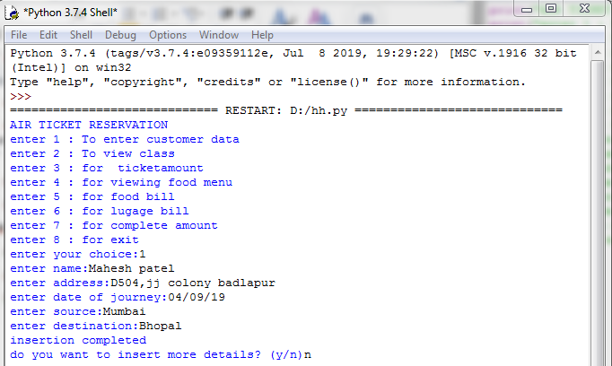

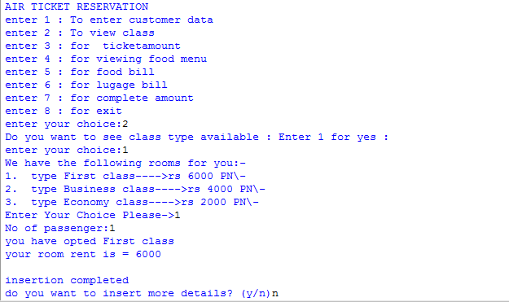

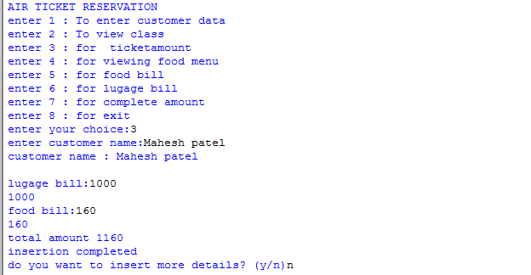

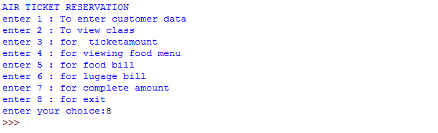

**Future enhancements**

1. The solutions are given as a proposal. The suggestion is revised on user request and optimal changes are made. This loop terminates as soon as the user is gratified with the proposal.
2. So on the whole, system analysis is done to improve the system performance by monitoring it and obtaining the best throughput possible from it. Therefore system analysis plays a crucial role in designing any system.
3. This is basically an interface of global distribute system to carry out reservation on desired airline from any place.
4. Airline reservation system make the life of passengers very easy as they don’t need to stand in queues for getting their seats reserved.
5. They can easily make reservation of any airline just from a single system. On the other hand, it also remove an extra burden from the Airline Department as most of the passengers and travel agencies use this service instead of making reservations from the counters.

**BIBLIOGRAPHY**

1. <http://www.google.com/>
2. <http://en.wikipedia.org>

3. Computer science with python

by Sumita Arora